Stats test 3 answers

The following Excel functions may be useful:

AVERAGE

NORM.DIST

NORM.INV

SQRT

STDEV.S

T.DIST

T.INV

**A sample yields a 95% confidence interval for a population proportion p as 0.92 ± 0.06. Which of the following interpretations of the confidence interval is invalid?**

the probability that p lies between 0.86 and 0.98 is 95%

Response Feedback: The population proportion is not a random variable, so a probability statement is incorrect

**Which of the following tests should always be one-sided?**

the contingency table test for independence

**If it is known that a test statistic lies in the rejection region at the 5% level of significance, what must be true of the associated p-value based on the same null and alternative hypotheses?**

it must be less than 5%

Response Feedback: The p-value embeds Ha

**A 95% confidence interval can be safely used to draw the same conclusion as a hypothesis test for the same parameter at the 5% level. When, and how?**

When the test is two-sided, H0 should be rejected if the value of the parameter therein sits outside the confidence interval

Response Feedback:

A confidence interval is always two-sided, and gives the likely values of the population parameter

**If the standardised score**

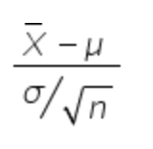

**has a standard normal distribution, why is the tn−1 distribution used in practice?**

|  |  |
| --- | --- |
| c. | both (a) and (b) |

**A random sample of 586 New Zealanders includes 356 who voted in the last general election. What is the sample proportion of individuals who did not vote in the last general election? (Give your answer to 2dp)**

0.392

Answer range +/-

0.01 (0.382 - 0.402)

Response Feedback: The sample proportion is: (number of successes) / n

**A researcher wishes to test the hypothesis H0 : µ = 20 using a sample with mean 25.5, standard deviation 8.6 and size 50. What is the test-statistic for this hypothesis test? (Give your answer to 1 decimal place.)**

4.52

Answer range +/-

0.1 (4.42 - 4.62)

Response Feedback: The test statistic is

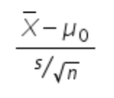

**In a sample of 29 males, 15 take QUAN 102 at university, while in a sample of 58 females, 19 take QUAN 102 at university. What is the pooled sample proportion of people taking QUAN 102? (Give your answer to 2 decimal places.)**

0.39

Answer range +/-

0.005 (0.385 - 0.395)

Response Feedback: pooled proportion = (total number of successes) / (total number of trials)

**A sample of n = 42 observations yields a test statistic of 1.84. The test statistic has a t-distribution with n-2 degrees of freedom, and the alternative hypothesis is upper-tailed. What is the associated p-value for this test? (Give your answer to 3 decimal places)**

0.0366

Answer range +/- 0.001 (0.0356 - 0.0376)

Response Feedback: Use the Excel function T.DIST

**A sample from a normally distributed population yields the following statistics:**

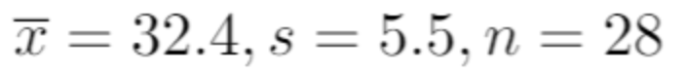

**The 97.5th percentile of the standard normal is 1.96, and of the t-distribution with 27 degrees of freedom is 2.052**

**What is the UPPER limit of the 95% confidence interval for the population mean based on this sample? (Give your answer to 1 decimal place.)**

34.5

Answer range +/-

0.01 (34.49 - 34.51)

Response Feedback: The CI is

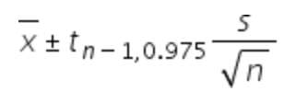

**An analyst wishes to estimate the average income with a margin of error of $425. A pilot study with a sample size of 100 produced a mean of $33,800 and a standard deviation of $6,375. What is the required sample size?**

**(You may use the value 1.96 in your calculation, rather than the value from the t(n-1) distribution.)**

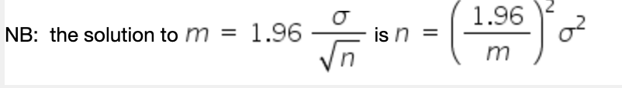

865

Answer range +/- 0 (865 - 865)

Response Feedback: n should always be rounded up.

**A regression yields the following output:**

**Coefficient Standard error t-statistic p-value**

**1.3840 0.5100 2.7137 0.0095**

**What will the test statistic be for a test of 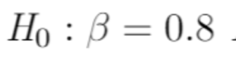 (to 3 decimal places)**

1.145

Answer range +/- 0.001 (1.144 - 1.146)

Response Feedback: The test statistic is (coefficient - value from H0) / (standard error)

**You wish to test the null hypothesis H0: p = 0.35 using a sample with sample proportion = 0.46 and n = 50. What is the value of the test statistic? (Write your answer to 2 decimal places)**

**NB: the sample proportion has standard error**

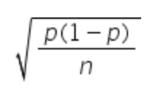

1.63

Answer range +/- 0.01 (1.62 - 1.64)

Response Feedback: Use the value from H0 in the standard error

**A researcher wishes to estimate a population proportion to within a margin of error of 0.02. A pilot sample of 40 observations has a sample proportion equal to 0.2. Using this sample proportion, how large a sample is needed to achieve the desired margin of error?**

**NB: the solution to** 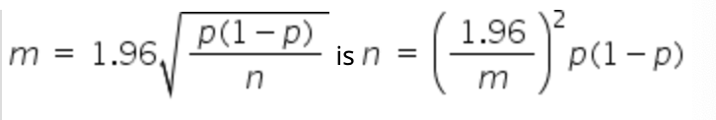

1,537

Answer range +/- 0 (1537 - 1537)

Response Feedback: n should always be rounded up.

**A sample of individuals is asked which of three alternative company logos they prefer. The resulting contingency table is:**

**Option 1 Option 2 Option 3**

**Male 31 12 24**

**Female 19 12 42**

**Assuming gender and preference are independent, what is the expected frequency of males who prefer option 2 (to 1 decimal place)? Note that n = 140**

11.5

Answer range +/- 0.01 (11.49 - 11.51)

Response Feedback: The expected frequency is (row total x column total) / n

**A researcher wishes to test the hypothesis H0: µ = 61 using a sample with mean = 64.5, standard deviation = 7.2 and n = 70.  What is the test-statistic for this hypothesis test?  (Give your answer to 1 decimal place.)**

**NB:** 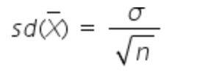

4.07

Answer range +/- 0.1 (3.97 - 4.17)

Response Feedback: The test statistic is

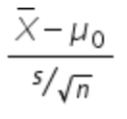

**A random sample of 141 Wellingtonians contains 54 who regularly use public transport. What is the sample proportion of people who do not regularly use public transport? (Give your answer to 2dp)**

0.617

Answer range +/- 0.01 (0.607 - 0.627)

Response Feedback: The sample proportion is: (number of successes) / n

**A sample of n = 25 observations yields a test statistic of -2.65. The test statistic has a t-distribution with n-1 degrees of freedom, and the alternative hypothesis is two-tailed. What is the associated p-value for this test? (Give your answer to 3 decimal places)**

0.014

Answer range +/- 0.001 (0.013 - 0.015)

Response Feedback: Use the Excel function T.DIST

**A sample yields a 95% confidence interval for a population mean µ as 4.2 to 21.8. Which of the following interpretations of the confidence interval is incorrect?**

the probability that µ lies between 4.2 and 21.8 is 95%

Response Feedback: The population mean is not a random variable, so a probability statement is incorrect

**A sample are asked which political party they support and which of three choices they prefer. The resulting contingency table is:**

**Prefer A Prefer B Prefer C**

**National supporter 17 22 11**

**Labour supporter 8 25 21**

**Assuming party support and preference are independent, what is the expected frequency of National supporters who prefer B (to 1 decimal place)? Note that n = 104**

22.6

Answer range +/- 0.01 (22.59 - 22.61)

Response Feedback: The expected frequency is (row total x column total) / n

**A sample are asked which political party they support and which of three choices they prefer. The resulting contingency table is:**

**Prefer A Prefer B Prefer C**

**National supporter 17 22 11**

**Labour supporter 8 25 21**

**Assuming party support and preference are independent, what is the expected frequency of Labour supporters who prefer A (to 1 decimal place)? Note that n = 104**

13

Answer range +/- 0.01 (12.99 - 13.01)

Response Feedback: The expected frequency is (row total x column total) / n

**A sample are asked which political party they support and which of three choices they prefer. The resulting contingency table is:**

**Prefer A Prefer B Prefer C**

**National supporter 17 22 11**

**Labour supporter 8 25 21**

**Assuming party support and preference are independent, what is the expected frequency of Labour supporters who prefer C (to 1 decimal place)? Note that n = 104**

16.6

Answer range +/- 0.01 (16.59 - 16.61)

Response Feedback: The expected frequency is (row total x column total) / n

**A regression yields the following output:**

**Coefficient Standard error t-statistic p-value**

**1.240 0.600 2.067 0.0507**

**What will the test statistic be for a test of  (to 3 decimal places)**

0.733

Answer range +/- 0.001 (0.732 - 0.734)

Response Feedback: The test statistic is (coefficient - value from H0) / (standard error)

**You wish to test the null hypothesis H0: p = 0.5 using a sample with sample proportion = 0.65 and n = 55. What is the value of the test statistic? (Write your answer to 2 decimal places)**

**NB: the sample proportion has standard error**

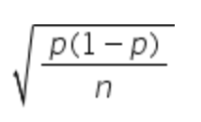

2.22

Answer range +/- 0.01 (2.21 - 2.23)

Response Feedback: Use the value from H0 in the standard error

**A researcher wishes to estimate a population proportion to within a margin of error of 0.07. A pilot sample of 75 observations has a sample proportion equal to 0.8. Using this sample proportion, how large a sample is needed to achieve the desired margin of error?**

**NB: the solution to** 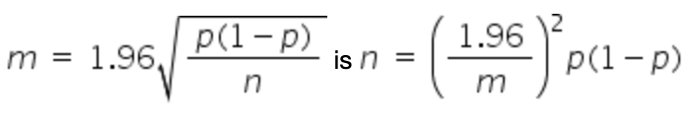

126

Answer range +/- 0 (126 - 126)

Response Feedback: n should always be rounded up.

**A researcher wishes to calculate a confidence interval for a population proportion, but finds that**

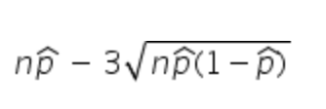

**is negative. Which of the following is TRUE?**

Increasing the sample size may solve the problem

**Let X have a binomial distribution with n trials and probability of success p, and let X′ have a normal distribution with mean np and variance np(1 − p). How and when can X′ be used to estimate P(X ≤ x)?**

Use P(X′ < x + 0.5) provided n is large and p is not too close to zero or one

**A difference of two sample means is 1.3 with a margin of error of 2.6. The corresponding confidence interval for the difference in the two population means is?**

1.3 ± 2.6

**In a confidence interval for a population mean µ, an increase in which of the following quantities will make the interval narrower?**

n

|  |
| --- |
|  |

**A random sample of 107 men contains 25 smokers. What is the sample proportion of non-smokers? (Give your answer to 2dp)**

0.766

Answer range +/- 0.01 (0.756 - 0.776)

Response Feedback: The sample proportion is: (number of successes) / n

**An analyst wishes to estimate the average height to within a margin of error of 2cm. A pilot study of a sample of 50 individuals found an average height of 173.5cm with a standard deviation of 15.8cm. What is the required sample size?**

**(You may use the value 1.96 in your calculation, rather than the value from the t(n-1) distribution.)**

**NB: the solution to** 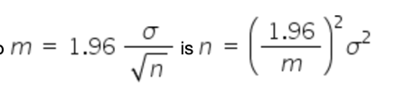

240

Answer range +/- 0 (240 - 240)

Response Feedback: n should always be rounded up.

**In a sample of 50 BA students, 18 take the train everyday, while in a sample of 49 BCom students, 6 take the train everyday. What is the pooled sample proportion of students who take the train everyday? (Give your answer to 2 decimal places.)**

0.24

Answer range +/- 0.005 (0.235 - 0.245)

Response Feedback: pooled proportion = (total number of successes) / (total number of trials)

**In a confidence interval for a population proportion p, a decrease in which of the following quantities will definitely make the interval wider?**

n

**A sample from a normally distributed population yields the following statistics:**

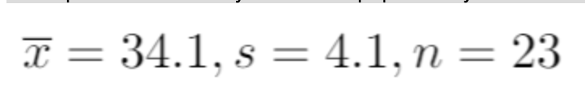

**The 97.5th percentile of the standard normal is 1.96, and of the t-distribution with 22 degrees of freedom is 2.074**

**What is the LOWER limit of the 95% confidence interval for the population mean based on this sample? (Give your answer to 1 decimal place.)**

32.3

Answer range +/- 0.01 (32.29 - 32.31)

Response Feedback: The CI is

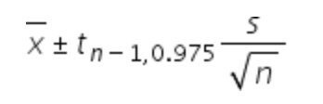

**A researcher wishes to test the hypothesis H0: µ = 17 using a sample with mean = 19.9, standard deviation =5.5 and n = 20. What is the test-statistic for this hypothesis test? (Give your answer to 1 decimal place.)**

**NB:** 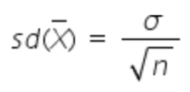

2.36

Answer range +/- 0.1 (2.26 - 2.46)

Response Feedback: The test statistic is

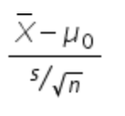

**You wish to test the null hypothesis H0: p = 0.55 using a sample with sample proportion = 0.7 and n = 38. What is the value of the test statistic? (Write your answer to 2 decimal places)**

**NB: the sample proportion has standard error**

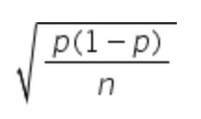

1.86

Answer range +/- 0.01 (1.85 - 1.87)

Response Feedback: Use the value from H0 in the standard error

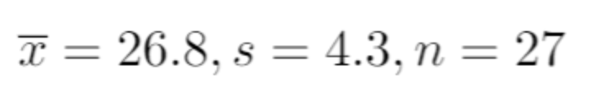

**The 97.5th percentile of the standard normal is 1.96, and of the t-distribution with 26 degrees of freedom is 2.056**

**What is the LOWER limit of the 95% confidence interval for the population mean based on this sample? (Give your answer to 1 decimal place.)**

25.1

Answer range +/- 0.01 (25.09 - 25.11)

Response Feedback: The CI is

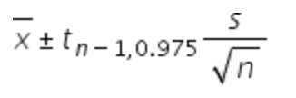

**A researcher wishes to estimate a population proportion to within a margin of error of 0.05. A pilot sample of 50 observations has a sample proportion equal to 0.75. Using this sample proportion, how large a sample is needed to achieve the desired margin of error?**

**NB: the solution to 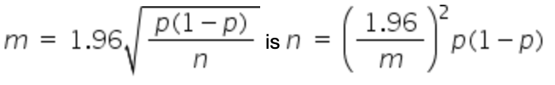**289

Answer range +/- 0 (289 - 289)

Response Feedback: n should always be rounded up.

**A sample yields a 95% confidence interval for a population proportion p as 0.21 to 0.42. Which of the following interpretations of the confidence interval is INCORRECT?**

the probability that p lies between 0.21 and 0.42 is 95%

**A regression yields the following output:**

**Coefficient Standard error t-statistic p-value**

**0.7291 0.1568 4.4650 0.0002**

**What will the test statistic be for a test of 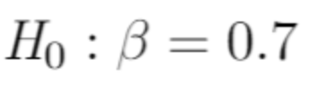(to 3 decimal places)**

0.186

Answer range +/- 0.001 (0.185 - 0.187)

Response Feedback: The test statistic is (coefficient - value from H0) / (standard error)

**You wish to test the null hypothesis H0: p = 0.5 using a sample with sample proportion = 0.65 and n = 55. What is the value of the test statistic? (Write your answer to 2 decimal places)**

**NB: the sample proportion has standard error**

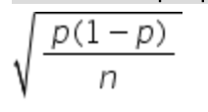

2.22

Answer range +/- 0.01 (2.21 - 2.23)

**A random sample of people contains 134 homeowners, and 206 who are not homeowners. What is the sample proportion of homeowners? (Give your answer to 2dp)**

0.394

Answer range +/- 0.01 (0.384 - 0.404)

**In a sample of 56 male university students, 34 work part time, while in a sample of 95 female university students, 35 work part time. What is the pooled sample proportion of part time workers? (Give your answer to 2 decimal places.)**

0.46

Answer range +/- 0.005 (0.455 - 0.465)

Response Feedback: pooled proportion = (total number of successes) / (total number of trials)

**A random sample of firms contains 32 with at least 50 employees, and 58 with fewer than 50 employees. What is the sample proportion of firms with fewer than 50 employees? (Give your answer to 2dp)**

0.644

Answer range +/- 0.01 (0.634 - 0.654)

Response Feedback: The sample proportion is: (number of successes) / (number of successes + number of failures)

**A researcher wishes to test the hypothesis H0: µ = 24.5 using a sample with mean = 22.5, standard deviation = 6.1 and n = 30. What is the test-statistic for this hypothesis test? (Give your answer to 1 decimal place.)**

-1.8

Answer range +/- 0.1 (-1.9 - -1.7)

Response Feedback: The test statistic is

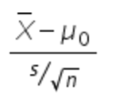

**A researcher proportion to within a margin of error of 0.02. A pilot sample of 80 observations has a sample proportion equal to 0.85. Using this sample proportion, how large a sample is needed to achieve the desired margin of error?**

**NB: the solution to **

1,225

Answer range +/- 0 (1225 - 1225)

Response Feedback: n should always be rounded up.

**A sample are asked their gender, and to compare their internet shopping patterns in the last six months to a similar period one year ago. The resulting contingency table is:**

**Less now Same now More now**

**Male 15 35 20**

**Female 13 29 14**

**Assuming gender and spending are independent, what is the expected frequency of males who spend the same now (to 1 decimal place)? Note that n = 126**

35.6

Answer range +/- 0.01 (35.59 - 35.61)

Response Feedback: The expected frequency is (row total x column total) / n

**A sample from a normally distributed population yields the following statistics:**

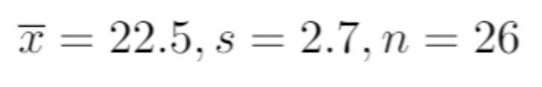

**The 97.5th percentile of the standard normal is 1.96, and of the t-distribution with 25 degrees of freedom is 2.060**

**What is the UPPER limit of the 95% confidence interval for the population mean based on this sample? (Give your answer to 1 decimal place.)**

23.6

Answer range +/- 0.01 (23.59 - 23.61)

Response Feedback: The CI is 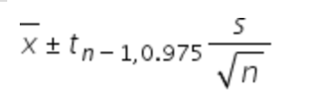

**An analyst wishes to estimate the average house price to within an margin of error of $9,560. A pilot study of 150 houses produces a mean of $550,000 and a standard deviation of $150,000. What is the required sample size?**

**(You may use the value 1.96 in your calculation, rather than the value from the t(n-1) distribution.)**

**NB: the solution to** 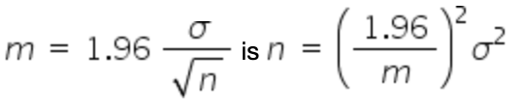

946

Answer range +/- 0 (946 - 946)

Response Feedback: n should always be rounded up.

**A sample of n = 15 observations yields a test statistic of -2.28. The test statistic has a t-distribution with n-1 degrees of freedom, and the alternative hypothesis is two-tailed. What is the associated p-value for this test?**

**(Give your answer to 3 decimal places)**

0.039

Answer range +/- 0.001 (0.038 - 0.040)

Response Feedback: Use the Excel function T.DIST

**You wish to test the null hypothesis H0: p = 0.18 using a sample with sample proportion = 0.25 and n = 55. What is the value of the test statistic? (Write your answer to 2 decimal places)**

**NB: the sample proportion has standard error**

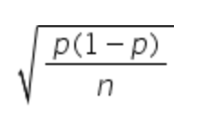

1.35

Answer range +/- 0.01 (1.34 - 1.36)

Response Feedback: Use the value from H0 in the standard error